APLIKASI ATM SEDERHANA
DENGAN BAHASA PEMOGRAMAN C++

oleh:
FELIX ANDREAS (1810631170119)
ROBBY FAISHAL BARI (1810631170156)



PROGRAM STUDI TEKNIK INFORMATIKA
FAKULTAS ILMU KOMPUTER
UNIVERSITAS SINGAPERBANGSA KARAWANG
KARAWANG
2019

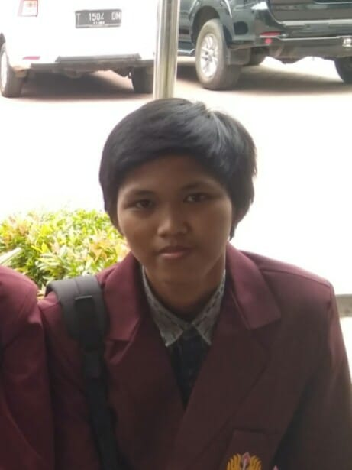
Nama : Robby Faishal Bari
NPM : 1810631170156
Kelas : 2-G
Penugasan : - Programmer ke-2
- Penggagas
- Pembuat PowerPoint
- Penyusun Laporan

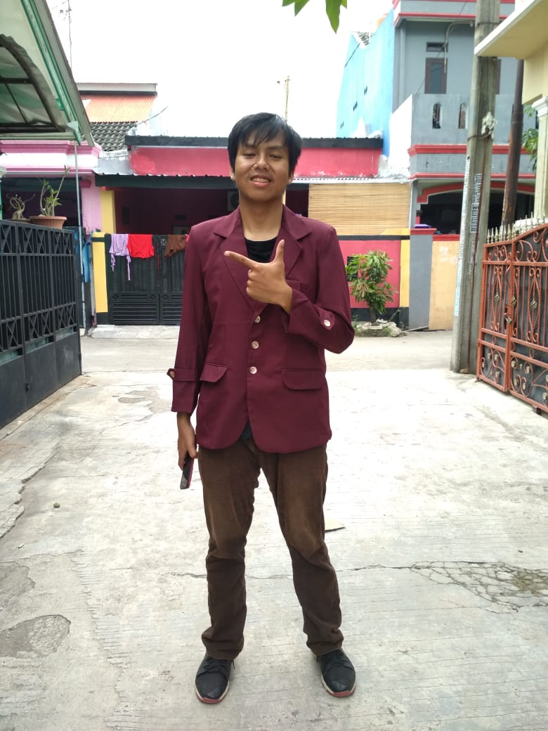
Nama : Felix Andreas
NPM : 1810631170119
Kelas : 2-G
Penugasan : - Programmer ke -1
- Penggagas
- Pembuat Flowchart
- Penyusun Laporan

Fasilitas Utama :
- Menampilkan form masukkan pin
- Menampilkan menu utama
- Menampilkan cek saldo
- Menampilkan transfer
- Menampilkan tarik tunai
- Menampilkan setor tunai

Fasilitas Tambahan :
- Fitur back & exit
- Fitur Loading

Bisnis Proses Aplikasi :

Program yang kami buat adalah Aplikasi ATM sederhana. Aplikasi ATM sederhana ini menggunakan bahasa pemrograman basis C++ . Pada ATM sederhana ini menggunakan system main utama yang menampilkan menu yaitu : cek saldo, transfer, penarikan tunai, penyetoran tunai, dan menu untuk exit. Untuk mengakses Menu Aplikasi ini di haruskan login dulu menggunakan pin yg sudah di atur yaitu “1234”. Kekurangan dari atm ini tidak menyediakan fitur membeli pulsa, mengisi paket data, membayar tagijhan listrik, membayar tagihan air, dan lain-lain.

Flowchart :
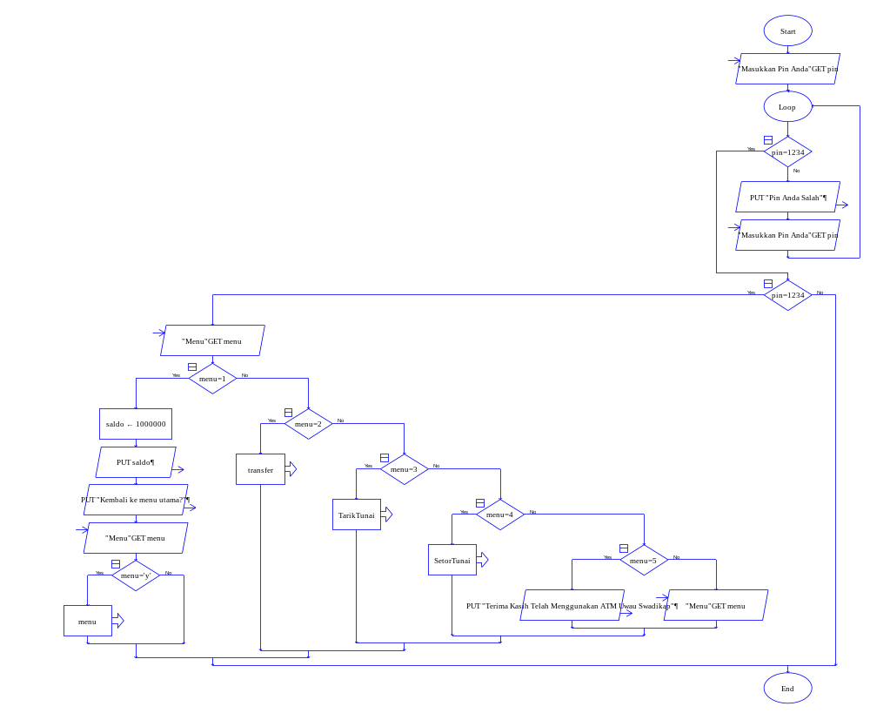

Source Code :
#include <iostream>
#include <string>
#include <windows.h>
#include <cstdlib>

using namespace std;

main()

{
system("Color 1f");
cout<<endl;
string sambutan="\t\t>>>>>>>>>>SELAMAT DATANG DI ATM SWADIKAP UUUWWWAAAUUU<<<<<<<<<<\n\n";
for (int x=0;x<=sambutan.length();x++){
cout<<sambutan[x];
for (double y=0;y<=9990000;y++){
}}
cout<<endl<<endl;
system("color 1f");
int pin=1234;
cout<<"========================================================="<<endl;
cout<<"||| SELAMAT DATANG DI ATM SWADIKAP UUUWWWAAAUUU |||"<<endl;
cout<<"||| PECAHAN RP 50000 |||"<<endl;
cout<<"=========================================================";
cout<<"\nMasukkan Pin Anda :";
cin>>pin;
while (!(pin==1234))
{
system("CLS");
cout<<"========================================================="<<endl;
cout<<"||| SELAMAT DATANG DI ATM SWADIKAP UUUWWWAAAUUU |||"<<endl;
cout<<"||| PECAHAN RP 50000 |||"<<endl;
cout<<"=========================================================";
cout<<"\n";
cout << "Pin yang anda masukkan salah" << endl;
cout << "\n\tMasukkan Pin : " ;
cin >> pin;
}
if (pin==1234)
{
cout << "Pin yang anda masukkan benar" << endl;
}
else
{
system("CLS");
cout << "Pin yang anda masukkan salah" << endl;
cout << "Masukkan Pin" << endl;
cin >> pin;
}
int pilihan, saldo=1000000, tf, tn, sisa, tujuan, top;
menu :
system("cls");
cout<<"========================================================="<<endl;
cout<<"||| ATM SWADIKAP UUUWWWAAAUUU |||"<<endl;
cout<<"||| PECAHAN RP 50000 |||"<<endl;
cout<<"=========================================================";
cout<<"\n";
cout<<"\tMENU : \n\n";
cout<<"\t\t1. Cek Saldo \n";
cout<<"\t\t2. Transfer \n";
cout<<"\t\t3. Tarik Tunai \n";
cout<<"\t\t4. Setor Tunai \n";
cout<<"\t\t5. Exit \n\n";
cout<<"\t Masukkan Pilihan Anda :";
cin>>pilihan;
switch(pilihan)
{
case 1:
{
menu1:
system("cls");
char a;
cout<<"========================================================="<<endl;
cout<<"||| ATM SWADIKAP UUUWWWAAAUUU |||"<<endl;
cout<<"||| PECAHAN RP 50000 |||"<<endl;
cout<<"=========================================================";
cout<<"\n";
cout<<" Saldo Anda : Rp. "<<saldo<<endl<<endl<<endl;
cout<<"\n";
cout<<" Kembali Ke Menu Utama y/n :"; cin>>a;
if (a=='y'||a=='Y')
{
goto menu;
}
else if(a=='n'||a=='N')
{
goto menu1;
}
{
cout<<"\n";
cout<<"Terimakasih telah menggunakan ATM UWWWAUUUUUUUU";
exit (0);
}
break;
}
case 2:
{
menu2:
system("cls");
char a;
cout<<"========================================================="<<endl;
cout<<"||| ATM SWADIKAP UUUWWWAAAUUU |||"<<endl;
cout<<"||| PECAHAN RP 50000 |||"<<endl;
cout<<"=========================================================";
cout<<"\n";
cout<<" Transfer \n";
cout<<"\n";
cout<<" Masukkan Rekening Tujuan : "; cin>>tujuan;
cout<<"\n";
cout<<" Masukkan Jumlah Transfer : Rp. ";
cin>>tf;
if (saldo>=tf)
{

}
else
{
while (!(saldo>=tf))
{
system("cls");
cout<<"=========================================================="<<endl;
cout<<"||| ATM SWADIKAP UUUWWWAAAUUU |||"<<endl;
cout<<"||| PECAHAN RP 50000 |||"<<endl;
cout<<"==========================================================";
cout<<"\n";
cout << "Maaf Saldo Anda Kurang" << endl;
cout<<"\n";
cout<<" Masukkan Rekening Tujuan : ";
cin>>tujuan;
cout<<"\n";
cout<<"Masukkan jumlah transfer : Rp. ";
cin >> tf;
}
}
cout<<"\n";
cout<<"Transaksi berhasil !"<<endl;
cout<<"\n";
sisa=saldo-tf;
cout<<" Jumlah Saldo Saat Ini : Rp. "<<sisa<<endl;
cout<<"\n";
cout<<"\nKembali Ke Menu Utama y/n :"; cin>>a;
if (a=='y'||a=='Y')
{
saldo=saldo-tf;
goto menu;
}
else if(a=='n'||a=='N')
{
goto menu2;
}

{
cout<<"\n";
cout<<"Terimakasih telah menggunakan ATM UWWWAUUUUUUUU";
exit (0);
}
break;
}
case 3:
{
menu3:
system("cls");
char a;
cout<<"========================================================="<<endl;
cout<<"||| ATM SWADIKAP UUUWWWAAAUUU |||"<<endl;
cout<<"||| PECAHAN RP 50000 |||"<<endl;
cout<<"=========================================================";
cout<<"\n";
cout<<" Tarik Tunai \n";
cout<<"\n";
cout<<" Masukkan Jumlah Yang Akan Ditarik : Rp. ";
cin>>tn;
if (tn%50000!=0 || tn<0)
{
cout<<"\n";
cout << "Tarik Uang dengan pecahan RP 50000\n";
cout<<"\n";
cout<<"Coba Ulang y/n :";
cin>>a;

if (a=='y'||a=='Y')
{goto menu3;}
else if (a=='n'||a=='N')
{
goto menu;
}
}
else {

if (saldo>=tn)
{
}
else
{
while (!(saldo>=tn))
{
system("cls");
cout<<"========================================================="<<endl;
cout<<"||| ATM SWADIKAP UUUWWWAAAUUU |||"<<endl;
cout<<"||| PECAHAN RP 50000 |||"<<endl;
cout<<"=========================================================";
cout<<"\n";
cout << "Maaf Saldo Anda Kurang" << endl;
cout<<"\n";
cout<<"Masukkan jumlah penarikan: Rp. ";
cin >> tn;
}
}
sisa=saldo-tn;
cout<<"\n";
cout<<" Sisa Saldo Sekarang : Rp. "<<sisa<<endl;
cout<<"\n";
cout<<" Silahkan Ambil Uang Anda, Jgn Lupa Sedekah"<<endl;
cout<<"\nKembali Ke Menu Utama y/n :"; cin>>a;

if (a=='y'||a=='Y')
{

saldo = saldo-tn;
goto menu;

}
else if(a=='n'||a=='N')
{
goto menu3;
}
{
cout<<"\n";
cout<<"Terimakasih telah menggunakan ATM UWWWAUUUUUUUU";
exit (0);
}
break;
}
case 4:
{
menu4:
system("cls");
char a;
cout<<"========================================================="<<endl;
cout<<"||| ATM UWWWAUUU SWADIKAP |||"<<endl;
cout<<"||| PECAHAN RP 50000 |||"<<endl;
cout<<"=========================================================";
cout<<"\n";
cout<<" Setor Tunai \n";
cout<<"\n";
cout<<" Masukkan Jumlah yang Akan disetor : Rp. ";
cin>>top;
if (top%50000!=0 || top<0)
{
cout<<"\n";
cout << "Setor Uang dengan pecahan RP 50000\n";
cout<<"\n";
cout<<"Coba Lagi y/n :";
cin>>a;
if (a=='y'||a=='Y')
{goto menu3;}
else if (a=='n'||a=='N')
{
goto menu;
}
}
else {
cout<<"\n";
sisa=saldo+top;
cout<<" Anda Berhasil Menyetor ! \n";
cout<<"\n";
cout<<" Jumlah saldo saat ini : Rp. "<<sisa<<endl;
cout<<"\n";
cout<<"\nKembali Ke Menu Utama y/n :"; cin>>a;
if (a=='y'||a=='Y')
{
saldo=saldo+top;
goto menu;
}
else if(a=='n'||a=='N')
{
goto menu4;
}
{
cout<<"\n";
cout<<"Terimakasih telah menggunakan ATM UWWWAUUUUUUUU";
exit (0);
}
break;
}
case 5:
{
char a;
system("cls");
cout<<"========================================================="<<endl;
cout<<"||| ATM UWWWAUUU SWADIKAP |||"<<endl;
cout<<"||| PECAHAN RP 50000 |||"<<endl;
cout<<"=========================================================";
cout<<"\n";
cout<<"Apakah Anda Yakin Akan Keluar : y/n \n";
cin>>a;
if (a=='y'||a=='Y')
{
cout<<"\n";
cout<<"Terimakasih telah menggunakan ATM UWWWAUUUUUUUU";
exit (0);
}
else if(a=='n'||a=='N')
{
goto menu;
}
}
}
}
}
}

SCREENSHOOT RUNNING PROGRAM :
- Tampilan Awal (Masukkan pin yg sudah di atur “1234”).
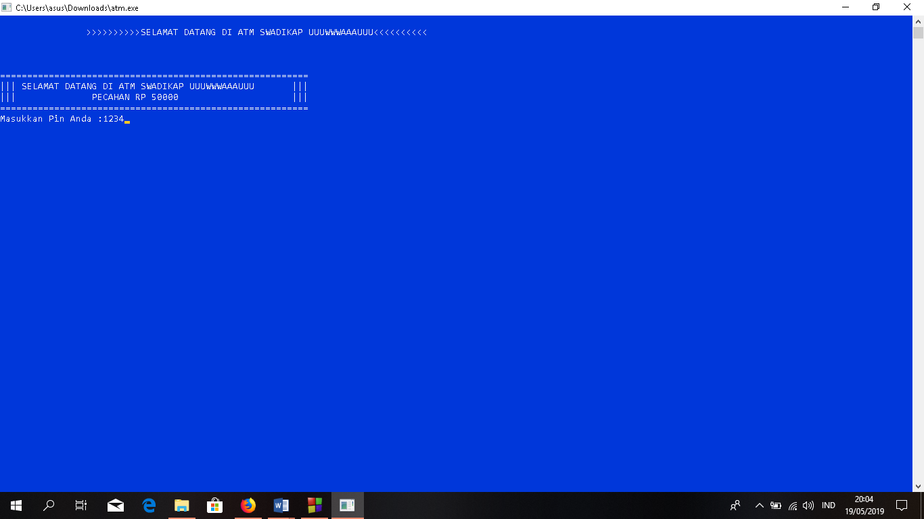
- Tampilan Menu Utama.
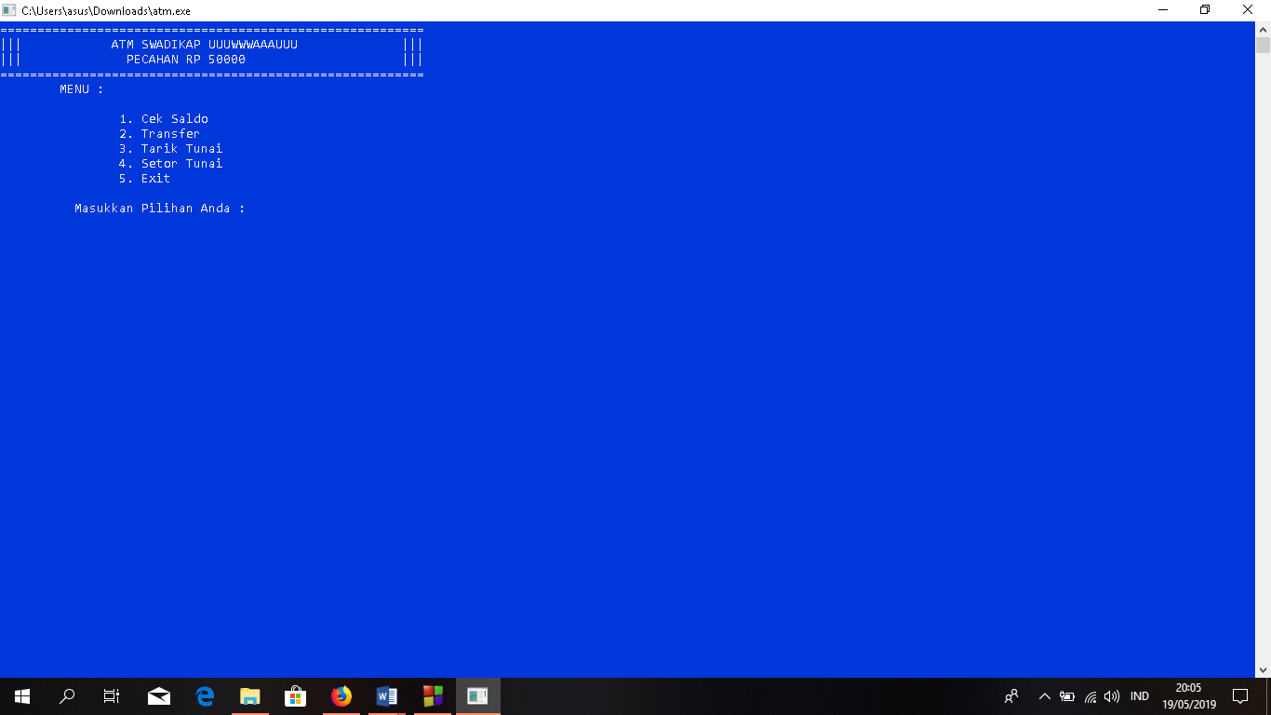

- Tampilan Menu Cek Saldo.
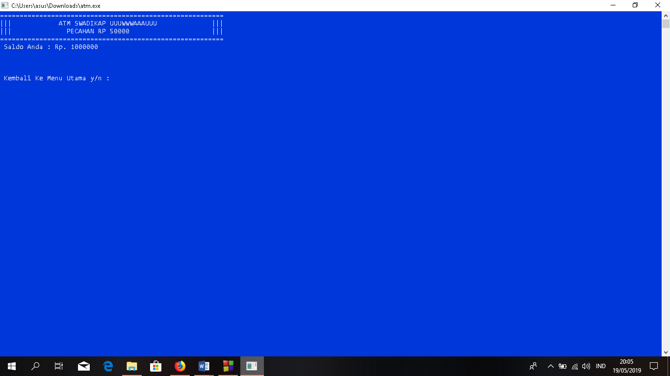
- Tampilan Menu Transfer (Jika Berhasil).
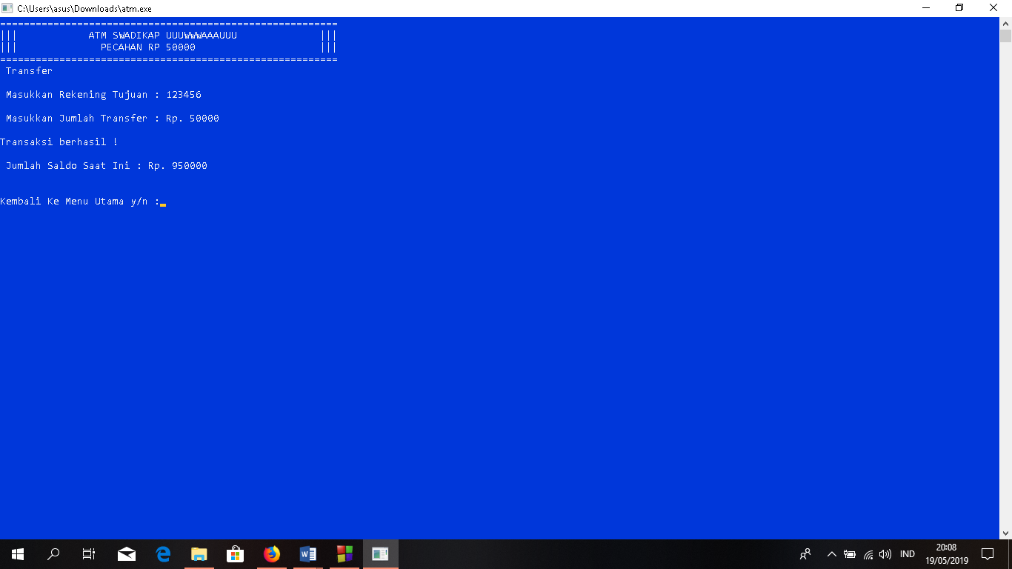

- Tampilan Menu Tranfer (Jika Gagal).
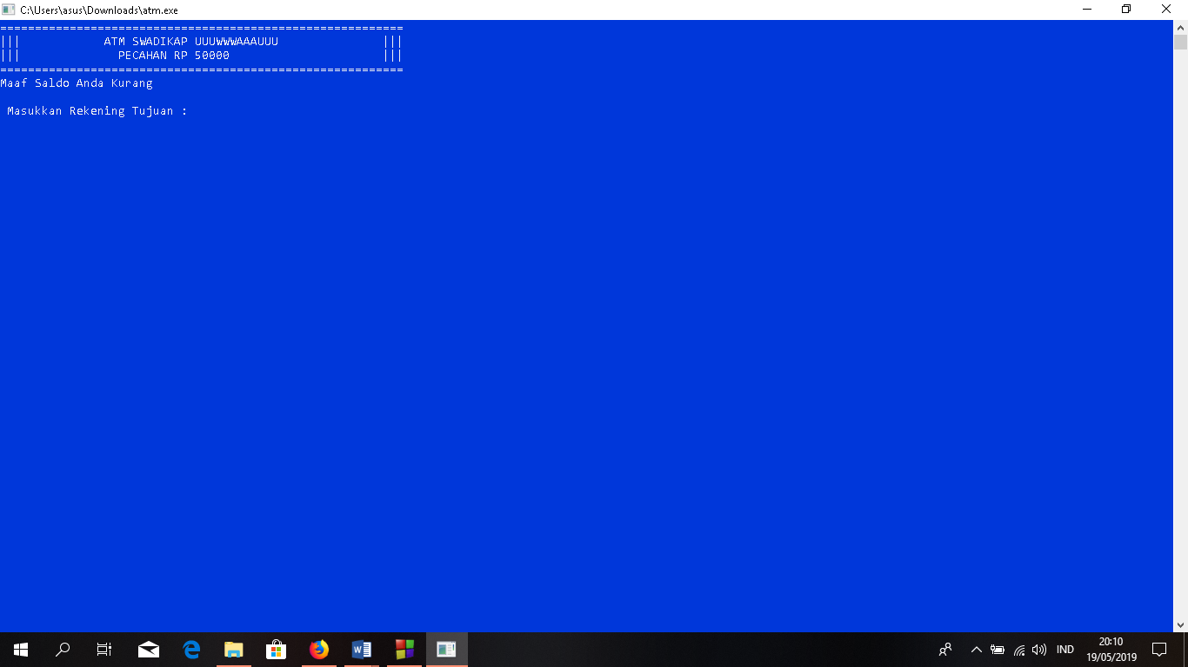
- Tampilan Menu Tarik Tunai (Jika Berhasil)
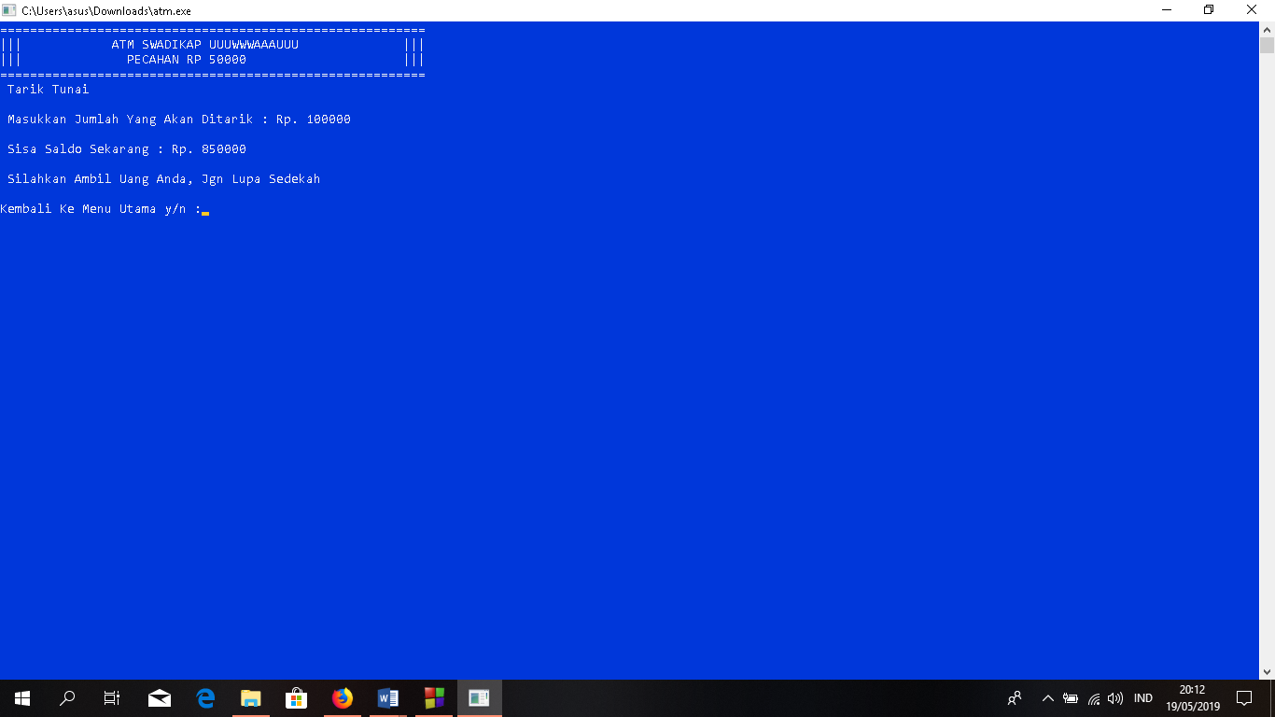

- Tampilan Menu Tarik Tunai (Jika Gagal)
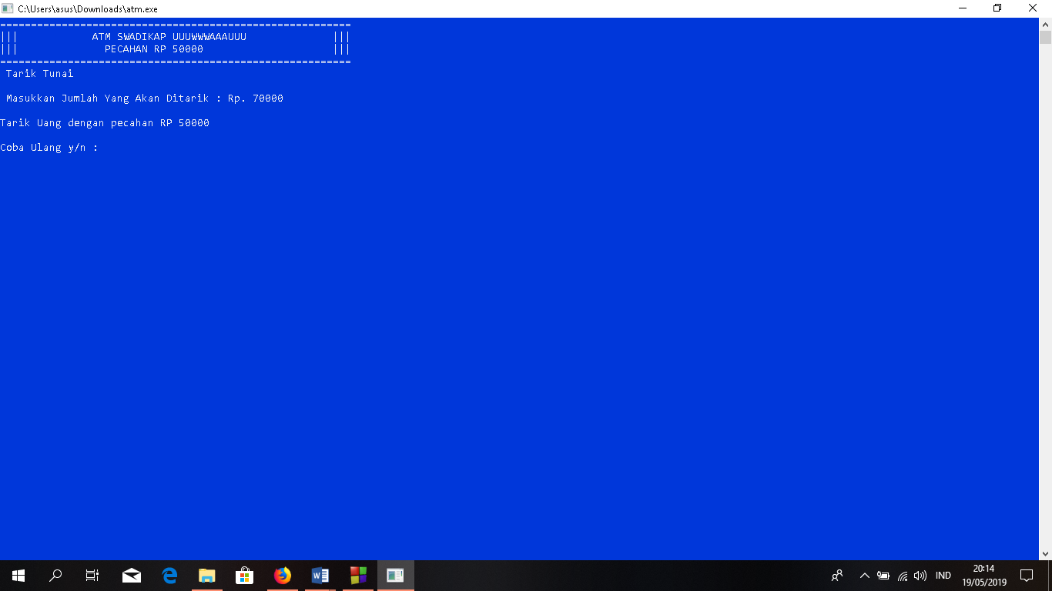
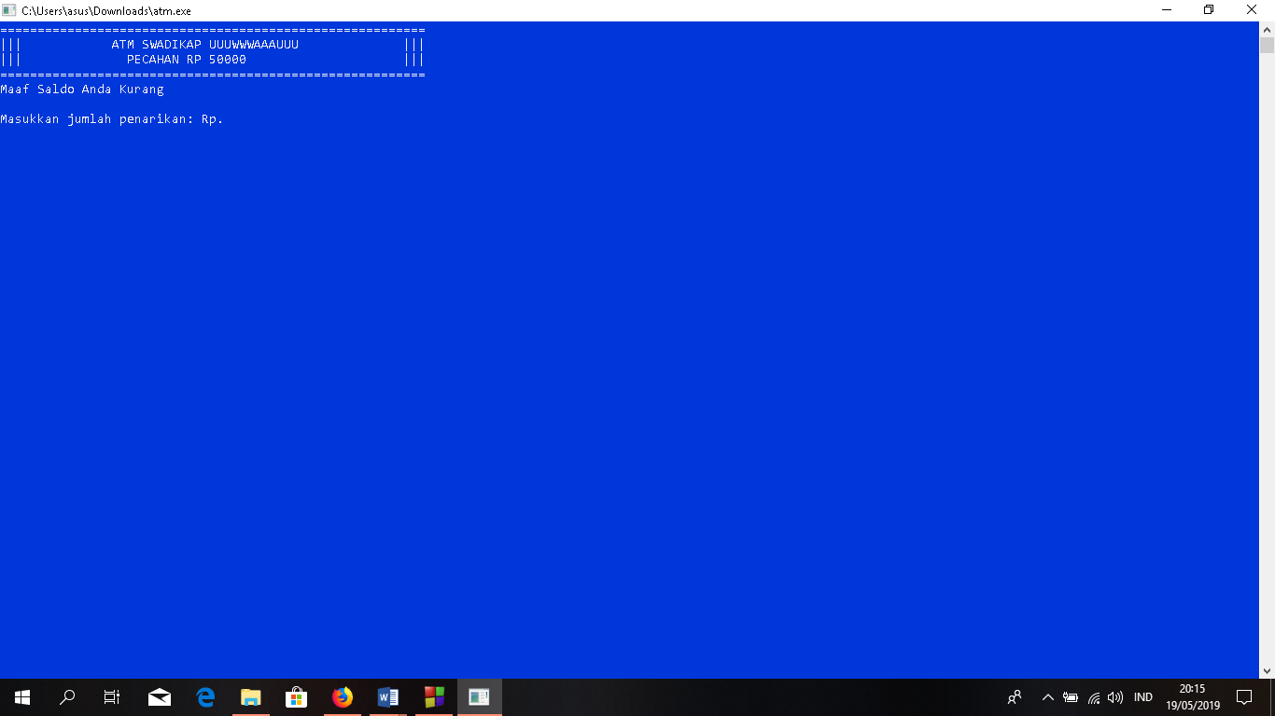

- Tampilan Menu Setor Tunai (Jika Berhasil)
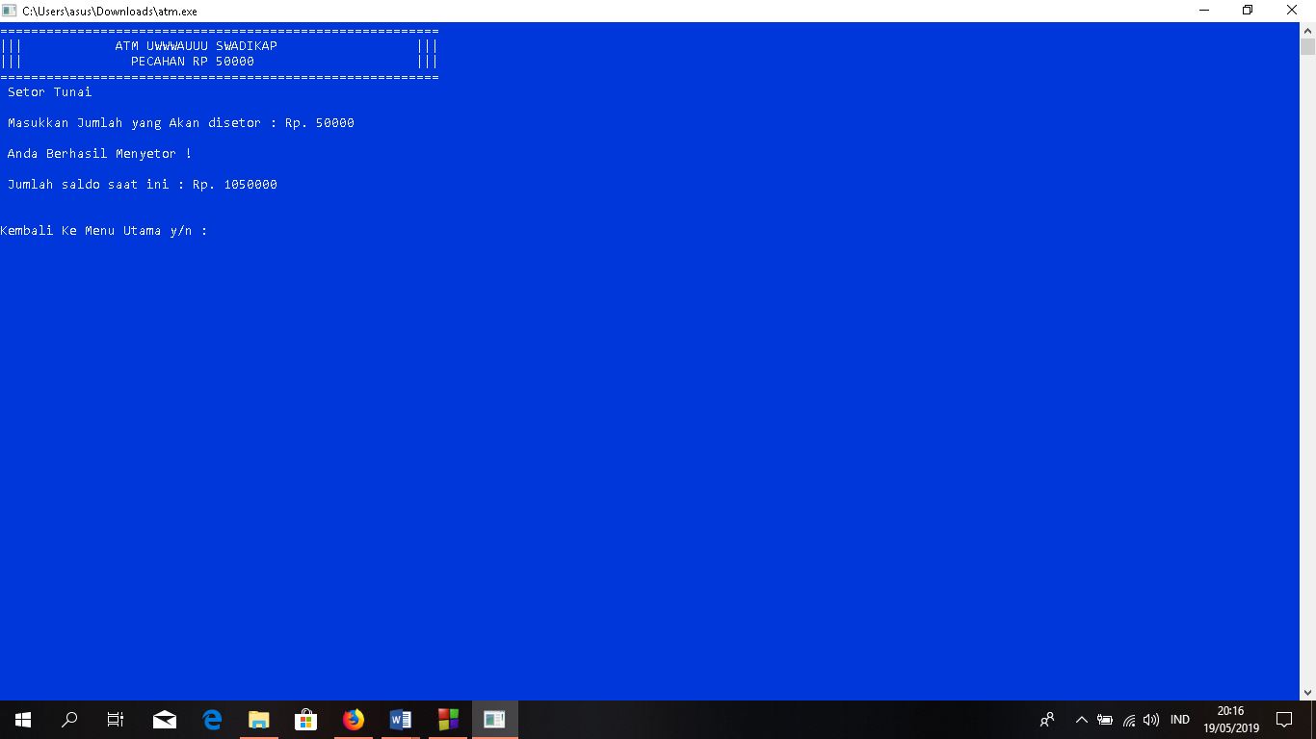
- Tampilan Menu Setor Tunai (Jika Gagal)
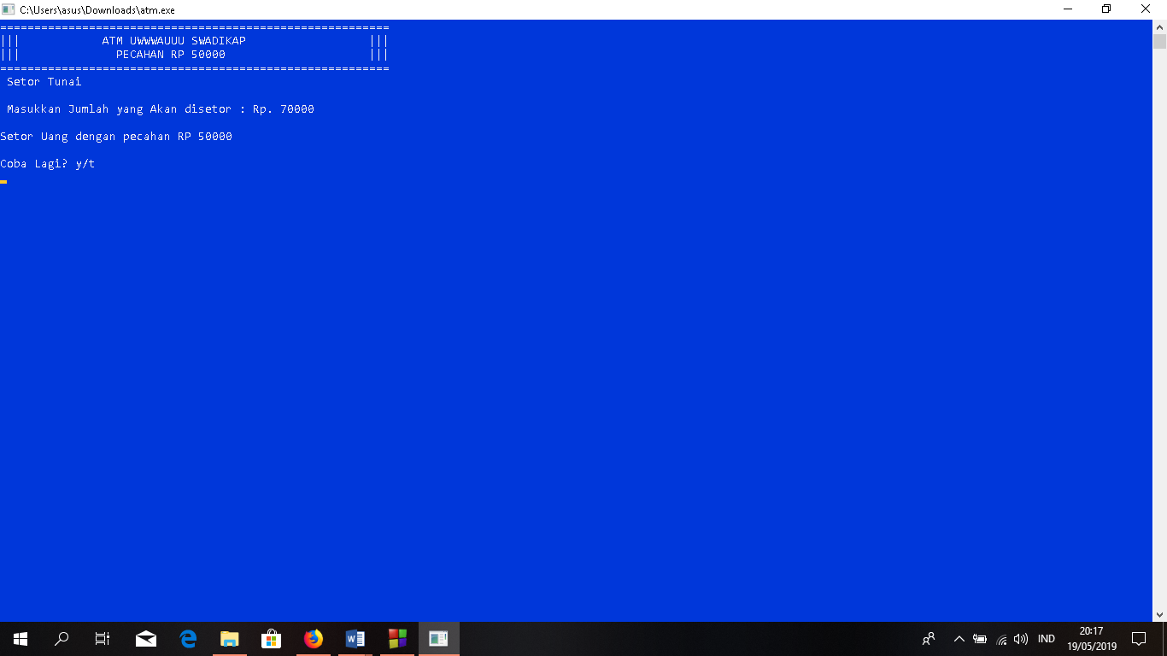

- Tampilan Menu Exit
